Mean Absolute Error:

There are many ways of measuring a model’s accuracy. However, the ***Mean Absolute Error***, also known as MAE, is one of the many metrics for ***summarizing and assessing the quality*** of a machine learning model.

What exactly does ‘ERROR’ in this metric mean ? We do a subtraction of Predicted value from Actual Value as below.

Prediction Error **→**Actual Value - Predicted Value

This prediction error is taking for each record after which we convert all error to positive. This is achieved by taking Absolute value for each error as below;

Absolute Error **→**|Prediction Error|

Finally we calculate the mean for all recorded absolute errors (Average sum of all absolute errors).

MAE = Average of All absolute errors

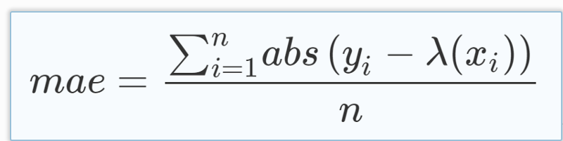

Mean Average Error Equation

Given any test data-set, Mean Absolute Error of your model refers to the mean of the absolute values of each prediction error on all instances of the test data-set. Prediction error is the difference between the actual value and the predicted value for that instance.

*Statistically, Mean Absolute Error* (MAE) refers to a the results of measuring the difference between two continuous variables. Let’s assume variables M and N represent the same phenomenon but have recorded different observations.

For a given scatter plot of x points, where point j has coordinates (Mj, Nj). Our Mean Absolute Error (MAE) will be the average vertical distance between each point and the N=M line. This is also known as the One-to-One line. MAE will also at this point be the average of total horizontal distance between each point and the N=M line.

In Machine Learning, MAE is a model evaluation metric often used with regression models. For a worked example of MAE calculation, do check my next article on Mean Absolute Error (MAE) ~ Sample Calculation.

The **average absolute deviation** (or **mean absolute deviation**) of a data set is the average of the [absolute](https://en.m.wikipedia.org/wiki/Absolute_value" \o "Absolute value)[deviations](https://en.m.wikipedia.org/wiki/Deviation_(statistics)) from a central point. It is a [summary statistic](https://en.m.wikipedia.org/wiki/Summary_statistics) of [statistical dispersion](https://en.m.wikipedia.org/wiki/Statistical_dispersion) or variability. In this general form, the central point can be the [mean](https://en.m.wikipedia.org/wiki/Arithmetic_mean), [median](https://en.m.wikipedia.org/wiki/Median), [mode](https://en.m.wikipedia.org/wiki/Mode_(statistics)), or the result of another measure of [central tendency](https://en.m.wikipedia.org/wiki/Central_tendency).

Several measures of [statistical dispersion](https://en.m.wikipedia.org/wiki/Statistical_dispersion) are defined in terms of the absolute deviation. The term "average absolute deviation" does not uniquely identify a measure of [statistical dispersion](https://en.m.wikipedia.org/wiki/Statistical_dispersion), as there are several measures that can be used to measure absolute deviations, and there are several measures of [central tendency](https://en.m.wikipedia.org/wiki/Central_tendency) that can be used as well. Thus, to uniquely identify the absolute deviation it is necessary to specify both the measure of deviation and the measure of central tendency

**Mean absolute deviation around the mean:**

The **mean absolute deviation** (MAD), also referred to as the "mean deviation" or sometimes "average absolute deviation", is the mean of the data's absolute deviations around the data's mean: the average (absolute) distance from the mean. "Average absolute deviation" can refer to either this usage, or to the general form with respect to a specified central point (see above).

MAD has been proposed to be used in place of [standard deviation](https://en.m.wikipedia.org/wiki/Standard_deviation) since it corresponds better to real life. Because the MAD is a simpler measure of variability than the [standard deviation](https://en.m.wikipedia.org/wiki/Standard_deviation), it can be useful in school teaching.

This method's forecast accuracy is very closely related to the [mean squared error](https://en.m.wikipedia.org/wiki/Mean_squared_error) (MSE) method which is just the average squared error of the forecasts. Although these methods are very closely related, MAD is more commonly used because it is both easier to compute (avoiding the need for squaring) and easier to understand.

disperse244